

LAB REPORT

CSE416: Web Engineering Lab

|  |
| --- |
| 01 [Report Number] |

Topic: HTML Tags with Attributes, Code Snippets, and Outcomes

Submitted To

**ENGR. NISHAT SADAF LIRA**

Lecturer

Department of CSE, Daffodil International University

Submitted By

Student ID: 221-15-4774

Section: 61_J1

Student Name: **SHORIF AKONDO**

Date of Lab Report Submission: 20th August, 2025

### **Lab Report-01: HTML Tags with Attributes, Code Snippets, and Outcomes**

### **1.** <html>

**Description**: Root element of an HTML document.

**Attributes**: lang

**Code**:



**Outcome**: Declares the start of the HTML document.

### **2.** <head>

**Description**: Contains meta-information about the document.

**Code**:

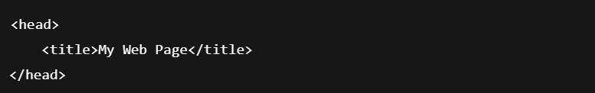

**Outcome**: Defines metadata like title, styles, etc.

### **3.** <title>

**Description**: Sets the title of the page (seen in the browser tab).

**Code**:



**Outcome**: Displays “My Web Page” in the browser tab.

### **4.** <body>

**Description**: Contains visible page content.

**Code**:

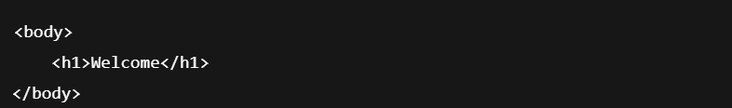

**Outcome**: Renders visible content.

### **5.** <h1> **to** <h6>

**Description**: Defines headings (h1 is largest).

**Code**:

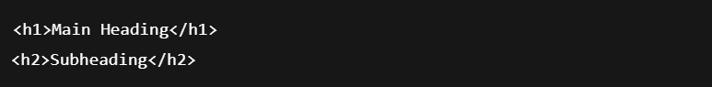

**Outcome**: Display headings in decreasing font sizes.

### **6.** <p>

**Description**: Paragraph tag.

**Code**:



**Outcome**: Adds paragraph text.

### **7.** <br>

**Description**: Inserts a line break.

**Code**:



**Outcome**: Breaks to a new line.

### **8.** <hr>

**Description**: Horizontal line divider.

**Code**:



**Outcome**: Renders a horizontal rule.

### **9.** <b> **/** <strong>

**Description**: Bold text.

**Code**:



**Outcome**: Displays bold text.

### **10.** <i> **/** <em>

**Description**: Italic text.

**Code**:



**Outcome**: Renders italic text.

### **11.** <a>

**Description**: Hyperlink.

**Attributes**: href, target

**Code**:



**Outcome**: Opens Google in a new tab.

### **12.** <img>

**Description**: Embeds images.

**Attributes**: src, alt, width, height

**Code**:



**Outcome**: Displays image.

### **13.** <ul>**,** <ol>**,** <li>

**Description**: Unordered & ordered lists.

**Code**:

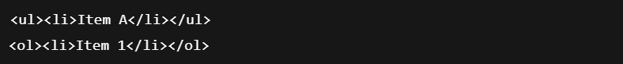

**Outcome**: Renders bullet/numbered lists.

### **14.** <table>

**Description**: Table structure.

**Code**:

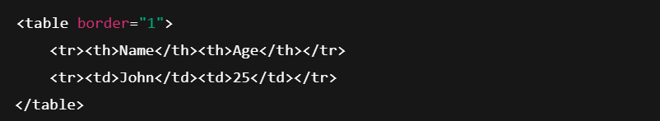

**Outcome**: Displays a table.

### **15.** <form>

**Description**: Form container.

**Attributes**: action, method

**Code**:

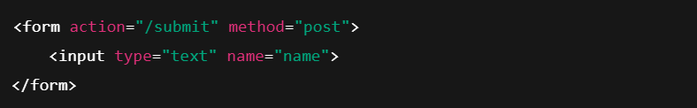**Outcome**: Creates a form.

### **16.** <input>

**Description**: Input field.

**Attributes**: type, name, value

**Code**:



**Outcome**: Email input box.

### **17.** <button>

**Description**: Clickable button.

**Code**:



**Outcome**: Renders a button.

### **18.** <label>

**Description**: Labels input fields.

**Code**:

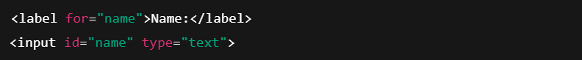

**Outcome**: Labels the input box.

### **19.** <div>

**Description**: Block-level container.

**Code**:



**Outcome**: Grouped content block.

### **20.** <span>

**Description**: Inline container.

**Code**:



**Outcome**: Inline styled text.

### **21.** <style>

**Description**: Embeds CSS.

**Code**:



**Outcome**: Applies background color.

### **22.** <script>

**Description**: Embeds JavaScript.

**Code**:

**Outcome**: Shows an alert.

### **23.** <meta>

**Description**: Metadata.

**Attributes**: charset, name, content

**Code**:



**Outcome**: Sets character encoding.

### **24.** <link>

**Description**: Links external files.

**Attributes**: rel, href

**Code**:



**Outcome**: Loads external CSS.

### **25.** <nav>

**Description**: Navigation bar.

**Code**:



**Outcome**: Adds navigation links.

### **26.** <header>

**Description**: Page header.

**Code**:



**Outcome**: Displays header content.

### **27.** <footer>

**Description**: Page footer.

**Code**:



**Outcome**: Footer section.

### **28.** <section>

**Description**: Logical sections of content.

**Code**:



**Outcome**: Groups related content.

### **29.** <article>

**Description**: Self-contained article.

**Code**:



**Outcome**: Blog-style layout.

### **30.** <iframe>

**Description**: Embeds another webpage.

**Attributes**: src, width, height

**Code**:



**Outcome**: Embeds a webpage.

### **Final Output Preview (Merged Tags Sample)**

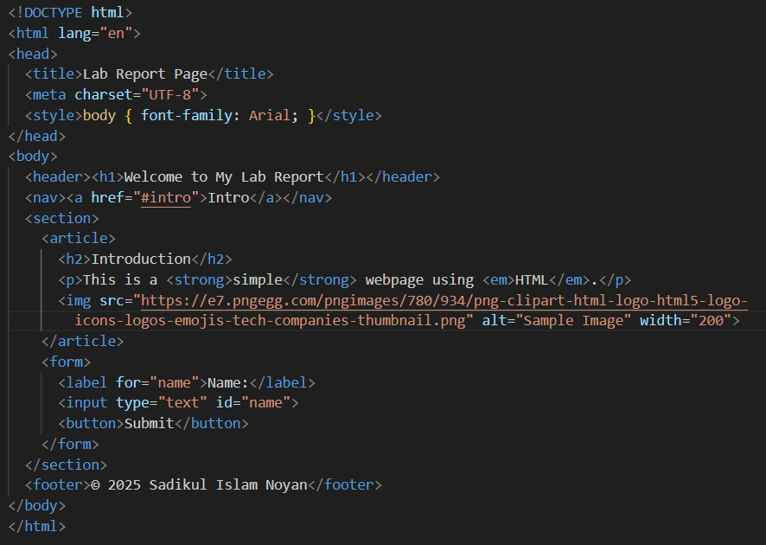

### **Output**

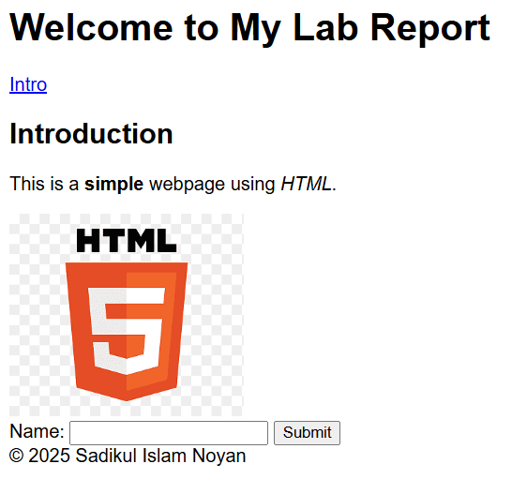

### **Conclusion**

These 30 HTML tags were used to structure and format content, create forms, link external resources, and embed scripts or other media. Together, they form the basic foundation of a fully functional and visually structured webpage.